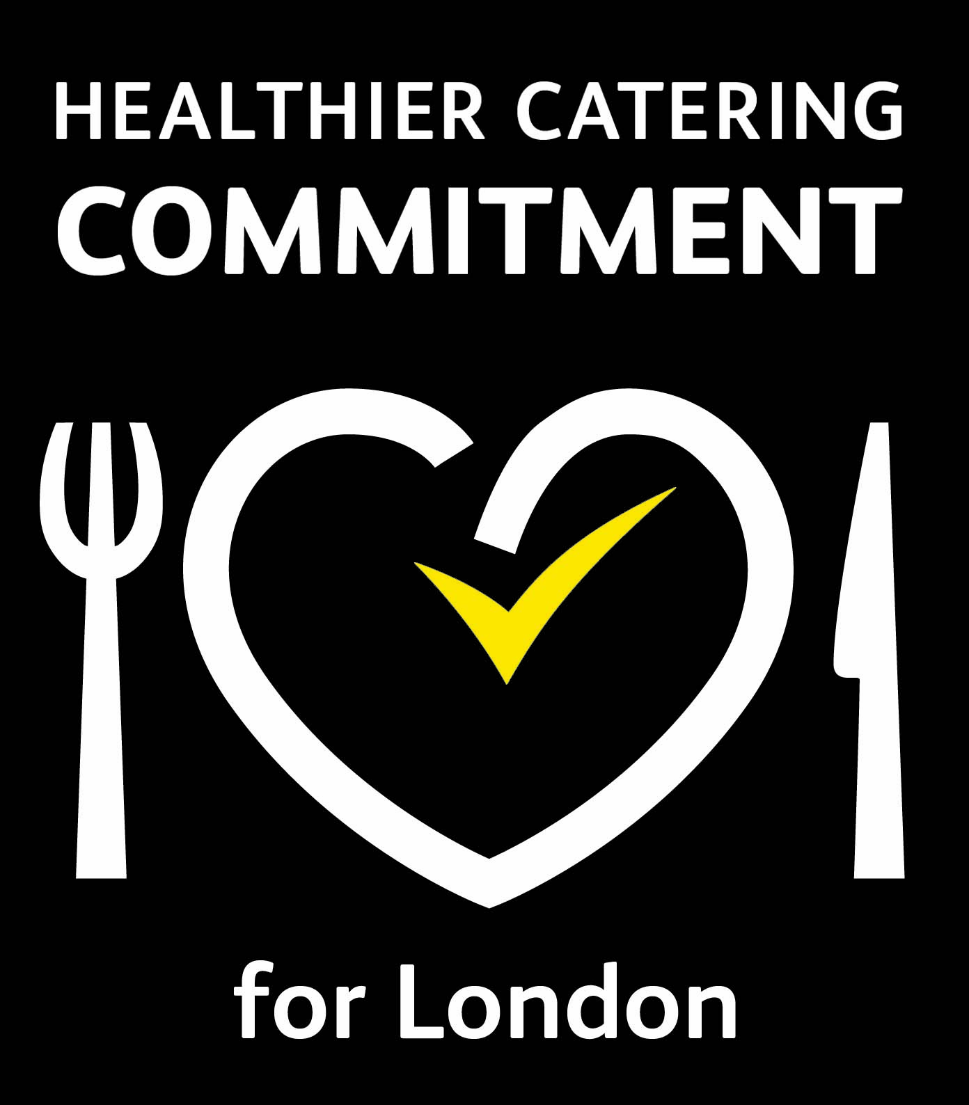

Healthier Catering Commitment for London
Application form

Name of business:
Name of applicant (proprietor):
Address of business:
Postcode:
Telephone No:
Mobile no:
Email:
Type of premises (restaurant, cafe, fish and chip, chicken takeaway, sandwich shop etc)

Do you have a written food safety management system (such as a SFBB manual)?
Yes 􀁔 No 􀁔
How many meals a day (or week) do you serve? Day Week
How many criteria do you think you comply with (minimum eight to be eligible)

Type of application: New 􀁔 Renewal 􀁔  

Please enclose details of your normal menu/selection and completed criteria sheet with your application.

If you need any further information or advice regarding the Healthier Catering Commitment, please do not hesitate to contact your local Environmental Health Department or email HCC@alehm.org.uk

Healthier Catering Commitment (HCC) is a voluntary healthier eating scheme which promotes healthier food choices to customers. We will share your name, address, telephone number and email address with the Environmental Health Department and the Public Health Department, ALEHM and the GLA to process the business data for purposes relevant to the award, including but not limited to
• assessing the food provision to decide on eligibility for the HCC
• sharing across relevant council and non-council websites promoting the HCC scheme and awards,
• sharing with relevant agencies for the purposes of evaluation and research.

The above data will be retained for the duration of the business participation in the HCC scheme.

Signed:.................................................. Date: ………………………………

Print name & job title................................................................................…

Please return your completed application form to your local authority, the contact details can be found on the Contacts page HealthierCateringCommitment.co.uk
or email to HCC@alehm.org.uk

